How to set up an email account
This guide shows you how to set up a free email account using Gmail.
Creating an email account will enable you to register for Knowsley Council’s Online Services and other websites.
Registering with other email providers such as Outlook and Yahoo is a similar process to the steps set out in this guide.
First Steps
- Type www.google.co.uk into the address bar at the top of the web page. | 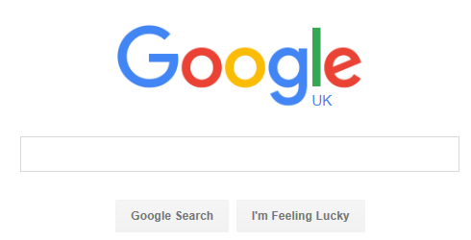
- Click on the Gmail link near the top left of the web page.
- Click on ‘Create Account’.
Choosing your email address
- To set up your new account, Google needs some information about you. Type in your first and last names. | Please note when you are applying for jobs it is important to have an email address that is professional and easy to understand, do not choose an email such as tinkerbelldust@gmail.com.
- To create an email you need to choose a user name. Your email address will be your user name followed by ‘@gmail.com’. Ideally it should be a combination of your first and last name. However, if your name is very common (for example John Smith), It’s very likely that email address is already in use. You may also want to include numbers in your email address such as your year of birth.

Choosing your Password
- Choose a password that is eight characters or more. Make sure your password is secure and one that you will remember. Secure passwords include combinations of upper case and lower case letters and numbers, for example News@10.

Verifying your Gmail account
- Type your birthday and gender.
- Enter your mobile telephone number or an alternative email address if you have one. This is so you can confirm it is your email account and will also help if you forget your log in details or have difficulty accessing your account in the future.

Prove you are not a robot
- This is a security measure, type in the letters and numbers as they appear on the screen.
- Agree to the terms of service by ticking the box. You may wish to untick the box next to Google ‘being able to use my account information’ for privacy and security.
- Click Next Step (You can add a profile picture at a later stage).
- Congratulations! You have created an email account.
- To start using email click on Continue to Gmail.

